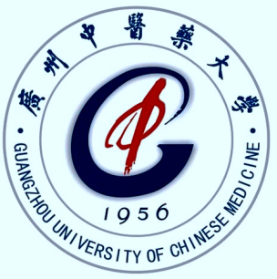

Neuroimaging by Evaluation Nerverenovate and Neuroplasticity of Acupuncture in Children with Cerebral Palsy

Zhenhuan LIU

Nanhai Maternity and Children Hospital Affiliated to Guangzhou University of Chinese Medicine CHINA

**Objective**: To investigate the effect of and Acupuncture on brain plasticity and motor development in children with cerebral palsy. Investigate effect on mechanism of apoptosis of brain nerve cells, regulating the expression of neurotrophic factors, promoting the remodeling of nerve synaptic structure and motor development in young rats with cerebral palsy.Two:To evaluate the effect and mechanism of acupuncture on cerebral palsy.Three:The nerve repair effect of acupuncture on cerebral palsy.Methods:In this study, 146 cases of brain injury and 1078 cases of cerebral palsy were included by randomized controlled study with ICF Gross motor function measure ,Peabody fine motor function, Gesell, muscle tension, joint activity, activity of daily living transcranial doppler,, skull B ultrasound, Brain Nuclear Magnetic Resonance Imaging MRI,Positron Emission Tomography SPECT, Diffusion tensor tractography evaluation method.

**Results**: the recovery rate of extracellular space (92.3%) was significantly higher than that of the control group (70.8%) (P <0.05), Transcranial Doppler,TCD total efficiency (79.3%) was significantly higher than that in the control group (51.8%) (P <0.05). Acupuncture to promoting the development of neurological and cognitive movement under 6 months children, effectively reduce the neurological sequelae.The total effective rate of the children with cerebral palsy was 87% in the acupuncture group, which was significantly higher than that of the control group (P <0.01). The total effective rate of Brain MRI was 59.55% in the acupuncture group and 13.25% higher than that in the control group (P <0.01). The total effective rate was 91.3% in the 1 year follow-up group, which was significantly higher than that in the control group (P <0.01). the FA value of white matter fiber bundle was significantly higher than that of acupuncture at 60 times (P <0.05). The recovery rate of ultrasonous brain injury (86.7%) in acupuncture group was significantly higher than that in control group (64.4%) (P <0.05). The recovery rate of brain SPECT in acupuncture group was 96.4%, which was significantly higher than that in the control group (P <0.01).

**Conclusion:** Acupuncture rehabilitation not only promote the development of white matter and gray matter in children with cerebral palsy, but also promote the brain function of children with cerebral palsy remodeling and compensation, and promote social adaptation, language and other cognitive function development, children with cerebral palsy movement and Fine motor function development and recovery, improve the children's self-care ability.

**Key Words**: Cerebral palsy;Acupuncture;Nerve repair;remodeling;motor function;

**Biography ;**Zhenhuan LIU professor of pediatrics,Pediatric acupuncturist Ph.D.tutor.He has been engaged in pediatric clinical and child rehabilitation for 40 years. Led the rehabilitation team to treat more than 40,000 cases of children with intellectual disability, cerebral palsy and autism from China and more than 20 countries,More than 26800 childrens deformity returned to school and society and became self-sufficient.The rehabilitation effect ranks the international advanced level.Vice-chairman of Rehabilitation professional committe children with cerebral palsy,World Federation of Chinese Medicine Societies.Visiting Profassor of Chinese University of Hong Kong in recent 10 years. .He is most famous pediatric neurological and rehabilitation specialists in integrated traditional Chinese and Western medicine in China.He has edited 10 books.He has published 268 papers in international and Chinese medical journals.

Email Lzh1958424@163.com

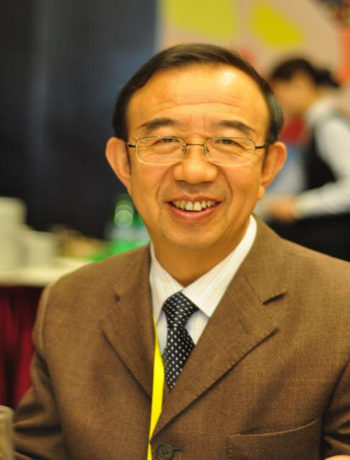picture



Presenter Name: Zhenhuan LIU

Type of Presentation:Oral 008613923185885