I prefer: POSTER presentation

Abstract title
Adult laryngeal neurofibroma – guidelines for diagnosis and management

Ian Chi Yuan Loh, Sophocles Huixian Tan & Aixin Cheah
Department of Otolaryngology, Head & Neck Surgery
Changi General Hospital, Singapore
2 Simei Street 3, Postal Code: Singapore 529889
E-mail: sophocles_huixian_tan@cgh.com.sg

Abstract
We present a rare case of an isolated laryngeal neurofibroma in an adult patient. Upon reviewing all available literature to date, there has only been approximately 15 isolated reports of such a case found.

This gentleman was attended by us initially as a case for emergency airway access when he crashed intra-operatively while undergoing an unrelated elective surgical procedure; life-saving slash tracheostomy was promptly performed, and he was successfully resuscitated.

Subsequently while being under our care post-operatively, the patient was incidentally found to have a laryngeal mass on nasoendoscopic examination; he then underwent definitive subtotal carbon dioxide laser excision and histological diagnosis subsequently confirmed the mass to be a neurofibroma. He was discharged from inpatient care upon ensuring that his breathing and speech were both stable post-operatively; during his last outpatient review, the gentleman was clinically assessed to have made a full recovery without any complications.

Going forward, we are striving to further embark on an extensive and comprehensive literature review of all cases of adult laryngeal neurofibromatosis, comparing these cases with existing literature of paediatric NF-1 and NF-2 patients. Thereafter, we aim to publish a set of guidelines on recommendations with regard to standardizing screenings before surgery, determining prognosis from certain clinical parameters and discussing the pros and cons of various known treatment options, including modalities like micro-debrider, laser, robotic surgery and the newly described transcervical radiofrequency ablation technique. This will help ensure efficacy and accuracy of prompt diagnosis and intervention, which in turn will lead to better patient outcome potentially.

Keywords
Neurofibroma; Laryngeal mass; Carbon dioxide laser; Laryngeal tumour; Airway obstruction

Recent Publications
Botolinum toxin in rhinitis: Literature review and posterior nasal injection in allergic rhinitis
Edward Zhiyong Zhang, Sophocles Tan, Ian Loh
Laryngoscope - 2017 Nov;127(11):2447-2454. doi: 10.1002/lary.26616.

Biography

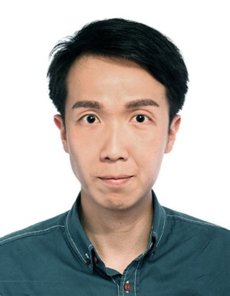

Dr Sophocles Tan
MBBS (Singapore)
Hospital Clinician
Department of Otolaryngology, Head & Neck Surgery
Changi General Hospital, Singapore
Email ID: sophocles_huixian_tan@cgh.com.sg
Phone No: +65-84999564

