I prefer: ORAL presentation

Abstract title

Faith as a Tool for Empowerment: Intersectionality, Women’s Well-being, and Trust in DFV Support  
(Times New Roman font: size18 point, centred paragraph)

**Maha Krayem Abdo1**

*1Muslim Women Australia, Sydney, Australia  
E-mail: ceo@mwa.org.au*

The abstract should be headed by a **title**, **name(s)** **and complete address (es) of the author(s).** Please underline the name of the author who will present the paper.

**Abstract (approximately 250-300 words limit)**

Abstract should give clear indication of the objectives, scope, results, methods used, and conclusion of your work. One figure and one table can be included in your results and discussions.

*This presentation explores the role of faith as a tool for empowerment in the context of women experiencing violence, emphasizing the intersectionality of faith, well-being, trust, and community-centred support. It examines how Muslim women’s leadership in the domestic and family violence (DFV) sector is deeply rooted in their faith, cultural identity, and lived experiences, shaping holistic, survivor-centred responses.*

*Using the case study of Muslim Women Australia, an organisation that has been established for over 40 years, and its DFV service, Linking Hearts, this presentation highlights how faith-informed practices provide agency, dignity, and culturally responsive support. It underscores the significance of trust in service delivery—particularly for women from culturally and linguistically diverse (CALD) backgrounds—who often seek safety and healing within community-led, faith-sensitive spaces. Despite structural barriers and policy shifts prioritizing generalist DFV service models, Muslim Women Australia has maintained a commitment to faith-based, culturally competent care, demonstrating the necessity of services that foster well-being by addressing the spiritual, psychological, and social dimensions of healing.*

*Drawing on victim-survivor experiences as well as organisational experiences, this presentation argues that faith is not only a source of resilience but also a critical framework for advocacy, trust-building, and systemic change in DFV response services. It calls for greater recognition of authentic community-centred approaches in the DFV sector to ensure holistic and meaningful support that strengthens both individuals and communities.*

**Keywords**

Please provide 5-10 Keywords separated by semicolons (“;”).

*Domestic and family violence, DFV, domestic violence, gender-based violence, faith, trust, women’s wellbeing, community-centered, victim-survivor*

**Recent Publications:** Minimum 3 publications to be included (Not mandatory)

**Biography** **(150 words limit)**

*Maha Krayem Abdo OAM is a passionate advocate for social justice and serves as the CEO of Muslim Women Australia (MWA). Under Maha’s leadership, MWA provides advocacy, policy advice, community development and domestic violence support for women and children for women from diverse cultural and religious backgrounds.*

*Maha knows the migrant experience firsthand having moved from Lebanon to Australia with her family in the 1960s. Maha’s work has helped provide new arrivals and other women with safety and assurance. She also works at a local, national and international level to advise governments on policy, services and strategies for Muslim and non-Muslim women.*

*A trained social worker, Maha’s contributions to human rights, equality and community cohesion have been recognised through numerous awards.*

**Presenting Author Details and Photo**

Full Name: Maha Krayem Abdo  
Email ID: ceo@mwa.org.au  
Phone No: +61403522972

LinkedIn: <https://au.linkedin.com/in/maha-krayem-abdo-oam>

Twitter: <https://twitter.com/MWA1983>   
Recent Photograph:

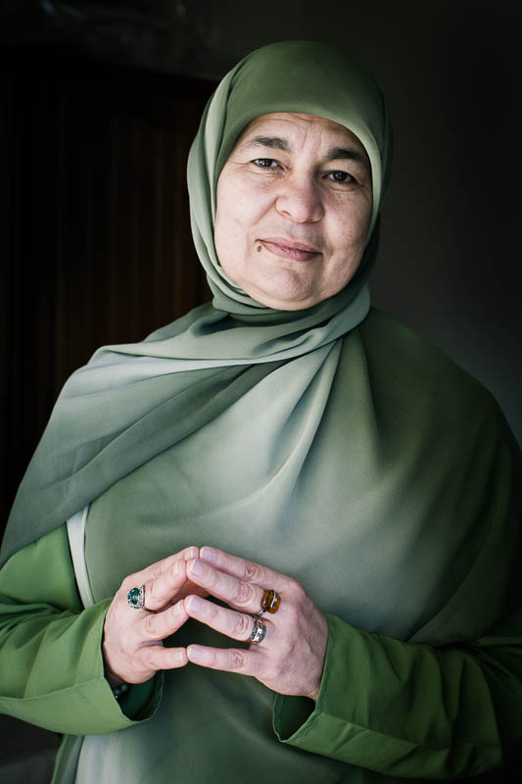 **General Instructions:**

* **Paper format:** Standard A4
* **Font and Size:** Times New Roman 11 pt, line space 1.5
* **Figures and Tables:** Proceedings will be printed in black and white. All figures/table must be integrated in the text. The figure caption style has the same font size as the main text. Please note that colored abstracts will be converted to black-and-white.

***Be sure to review one last time, including all authors data, before sending your abstract. Thank you.***